1)

a) In attached q1.LTS file

b)

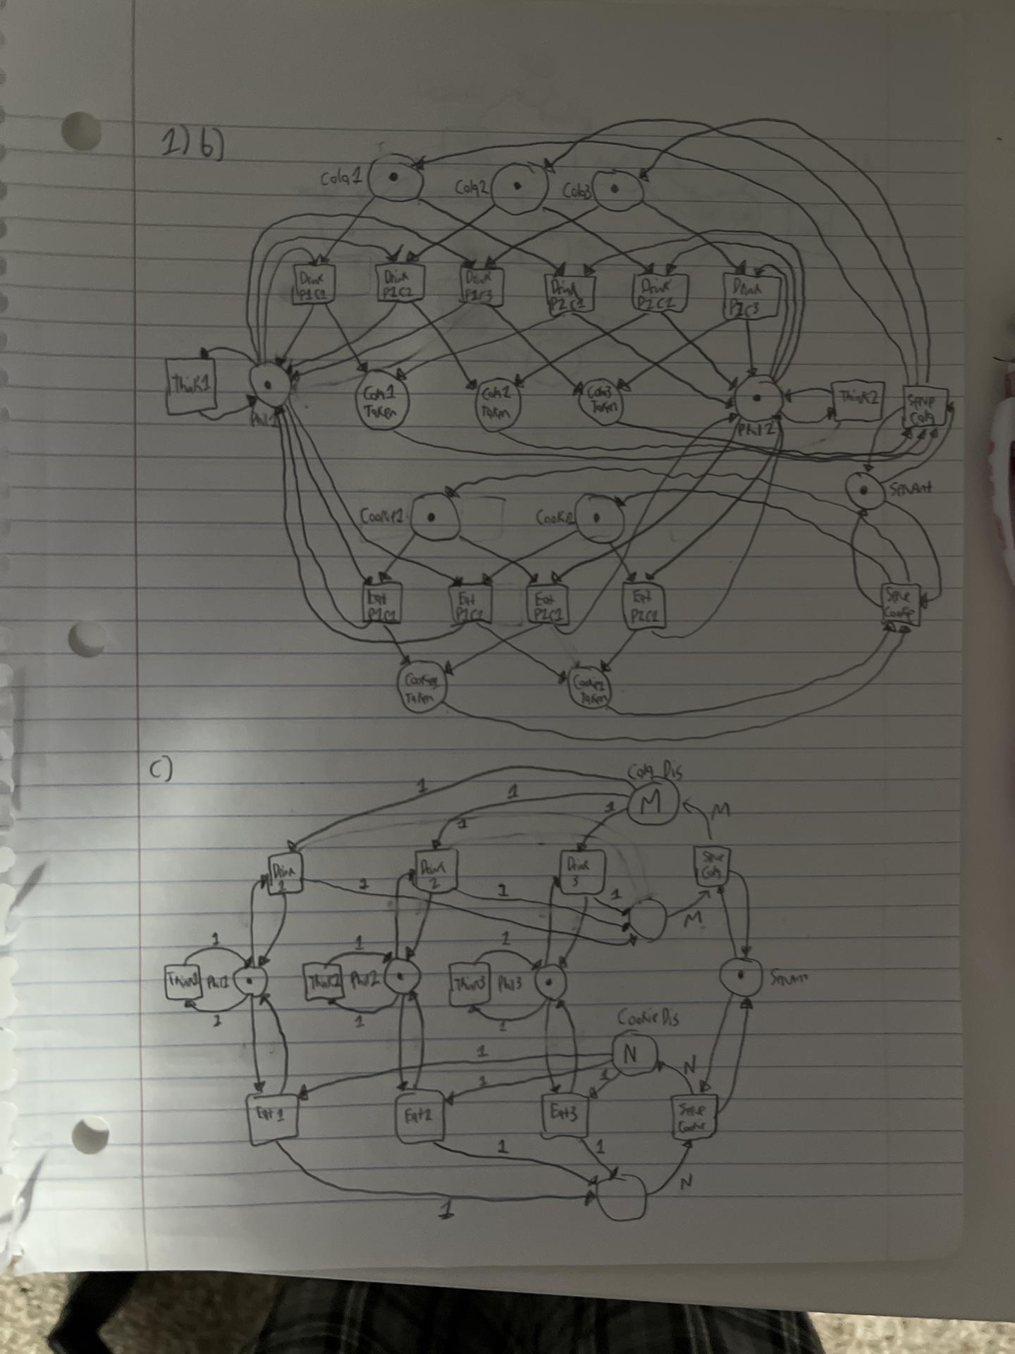

c)



d)

colour PHILOSOPHERS = with phil1 | phil2 | … | philk

colour SERVANT = with serv

colour COOKIES = Integers

colour COLAS = Integers

var p : PHILOSOPHERS

var s : SERVANT

var cook1, cook2 : COOKIES

var cola1, cola2 : COLAS

fun SERVECOOKIE cook2 = M

fun COOKIEEMPTY cook2 = M

fun SERVECOLA cola2 = N

fun COLAEMPTY cola2 = N

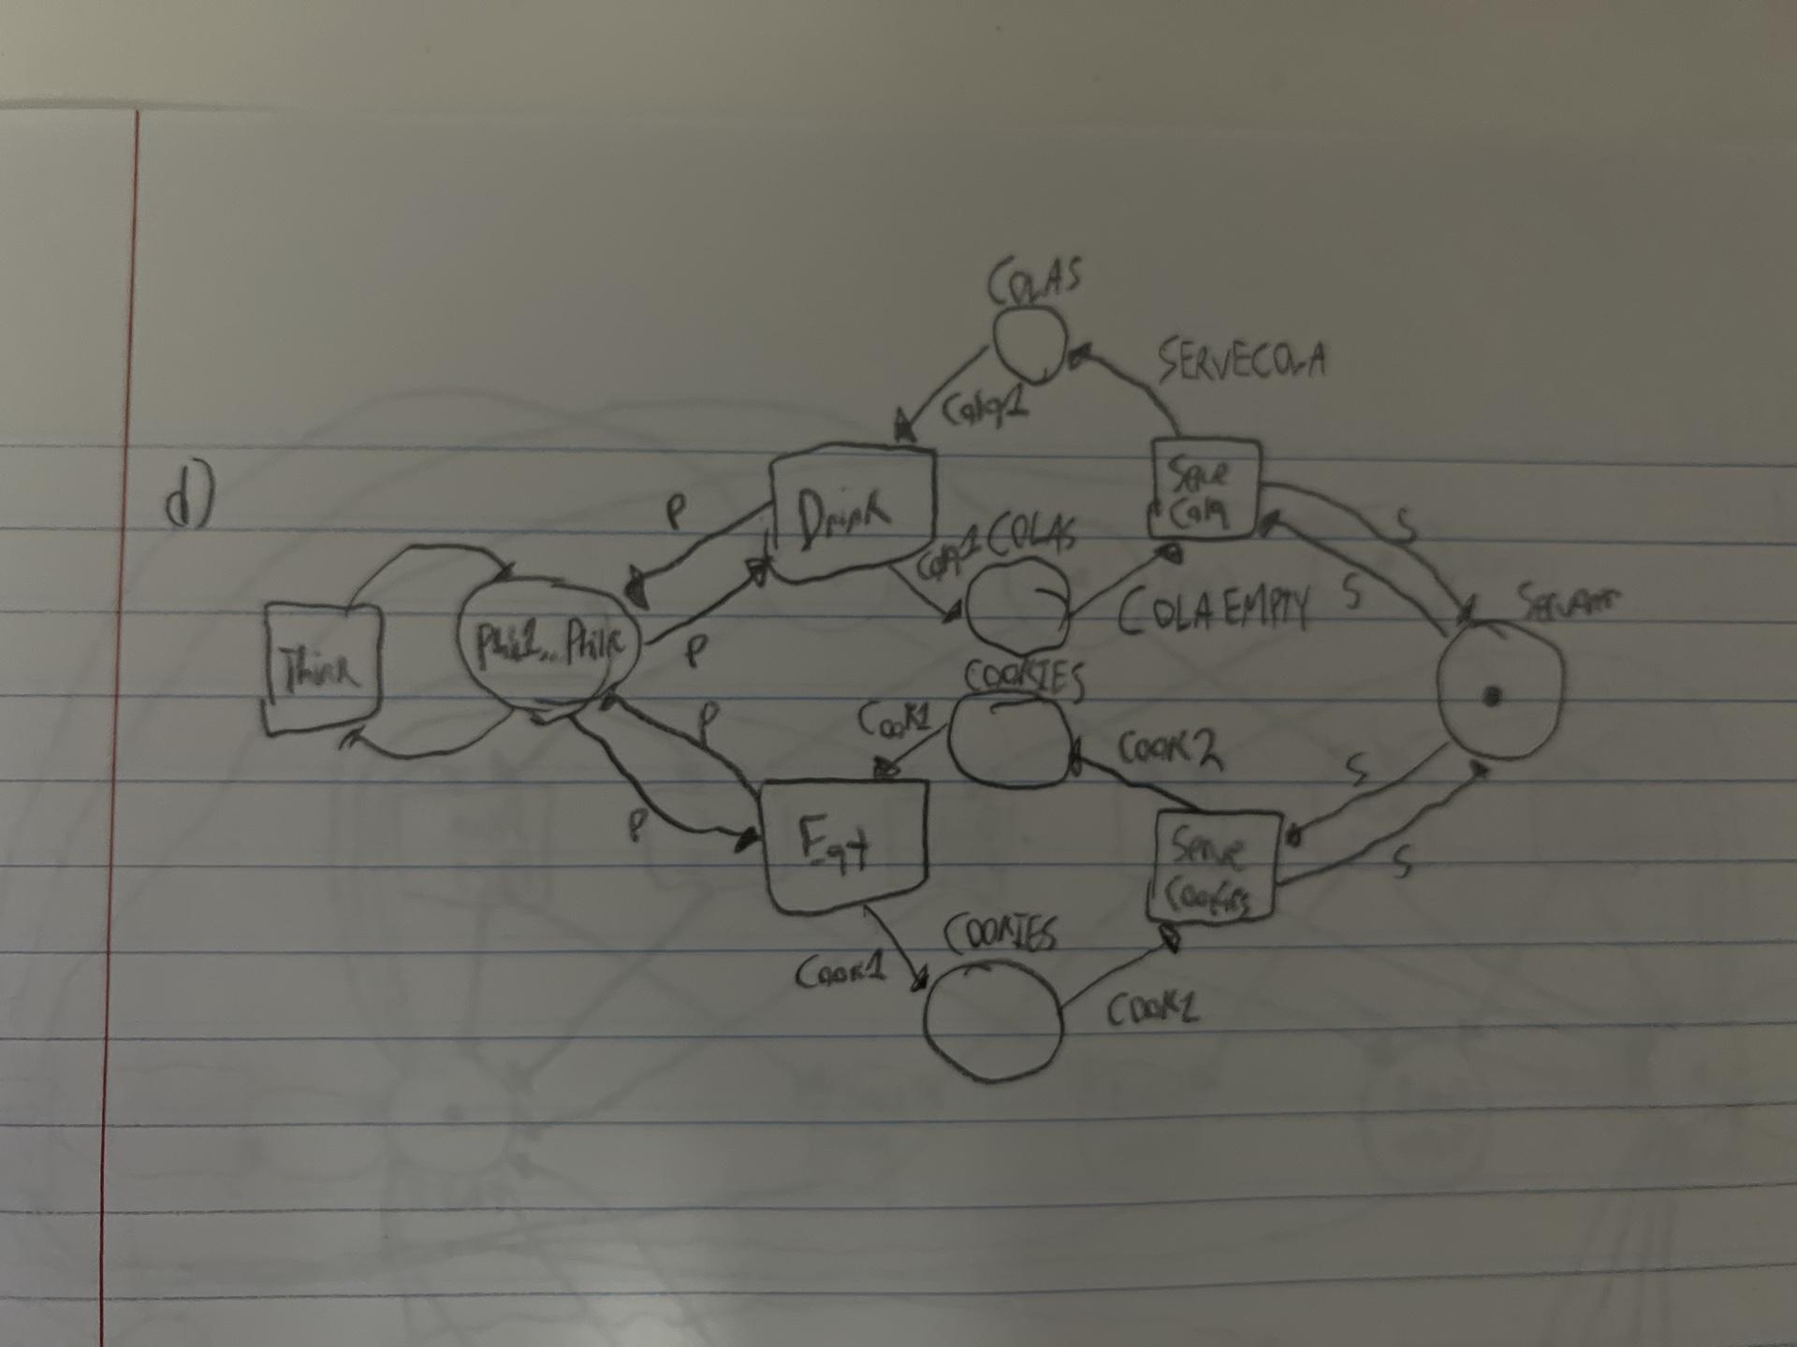

e)

In order of readability, it goes Coloured > Place/Transition > Elementary. The Elementary is closest to an FSP.

f) In attached q1.java file

2)

a) LTS found in q2.LTS attached.  
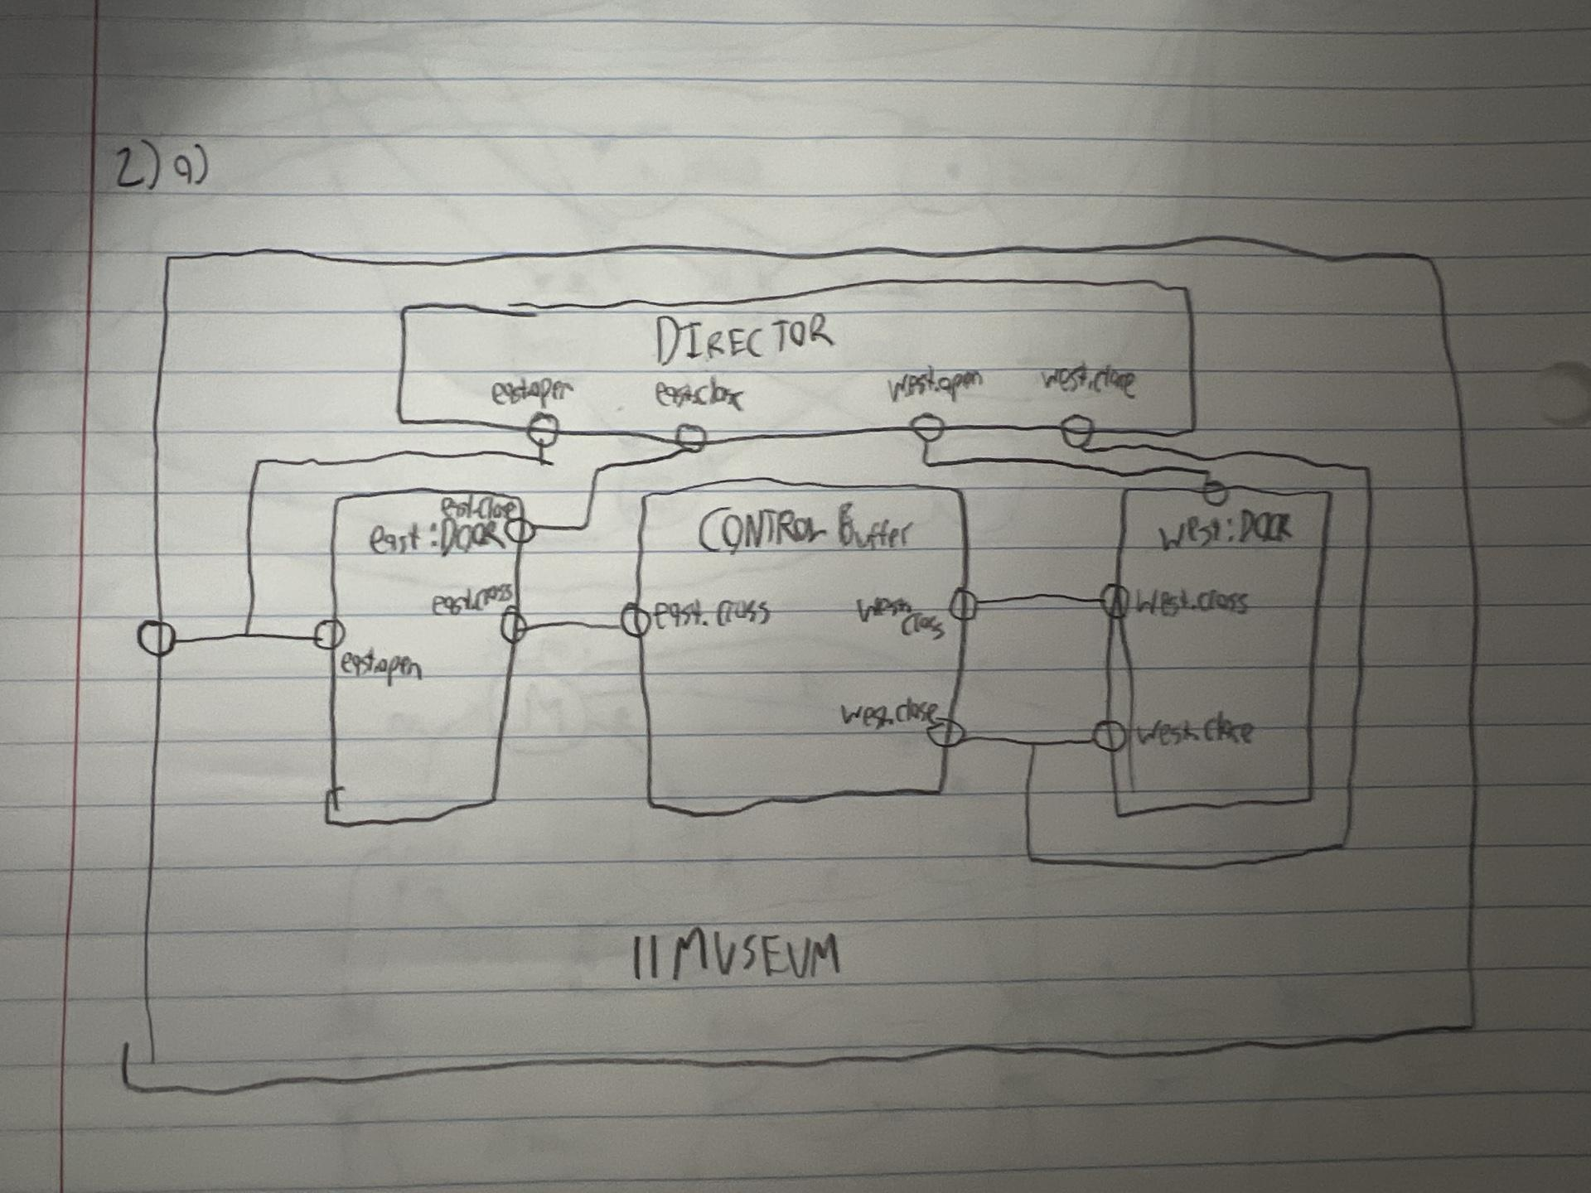

b)

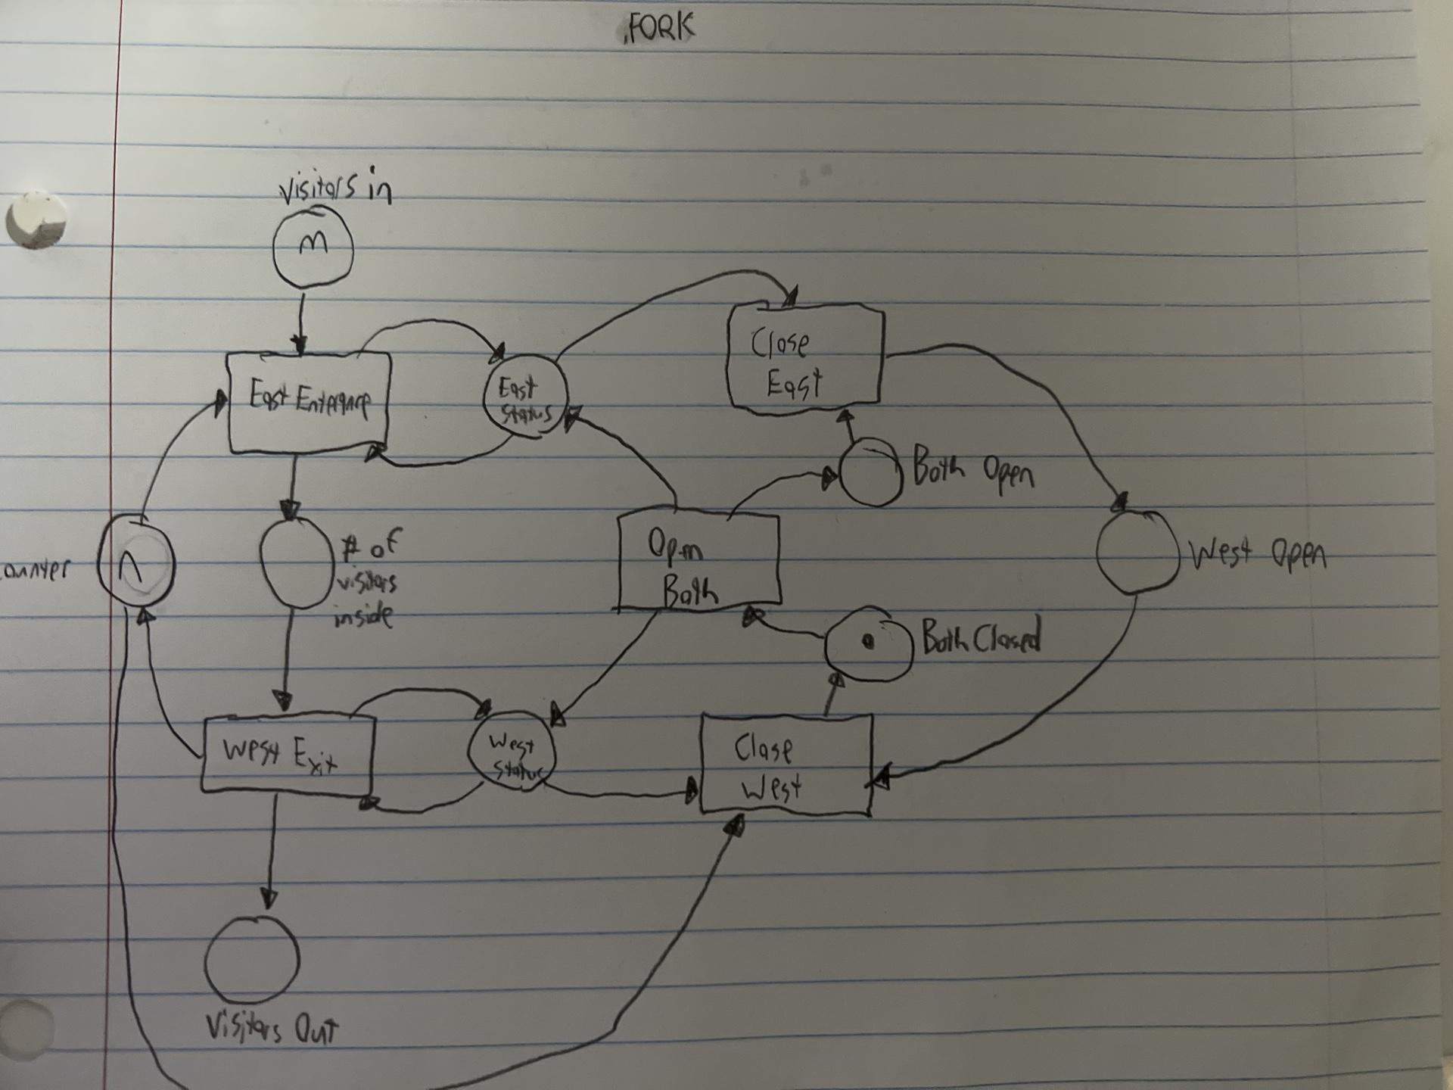

c) Found in q2.java

3)

Attached in q3.LTS. No, starvation will not occur when the car departure has lower priority.

4)

Attached in q4.LTS.

5)

colour PHIL = with phil1 | phil2 | phil3 | phil4 | phil5

colour FORK = with fork1 | fork2 | fork3 | fork4 | fork5

FirstFork : PHIL -> FORK

SecondFork : PHIL -> FORK

FirstForkR : PHIL -> FORK

SecondForkR : PHIL -> FORK

var p : PHIL

fun FirstFork p = case of phil1 -> fork2 | phil2 -> fork2 | phil3 -> fork4 | phil4 -> fork5 | phil5 -> fork5

fun SecondFork p = case of phil1 -> fork1 | phil2 -> fork3 | phil3 -> fork3 | phil4 -> fork3 | phil5 -> fork1

fun FirstForkR p = case of phil1 -> fork2 | phil2 -> fork2 | phil3 -> fork4 | phil4 -> fork5 | phil5 -> fork5

fun SecondForkR p = case of phil1 -> fork1 | phil2 -> fork3 | phil3 -> fork3 | phil4 -> fork3 | phil5 -> fork1

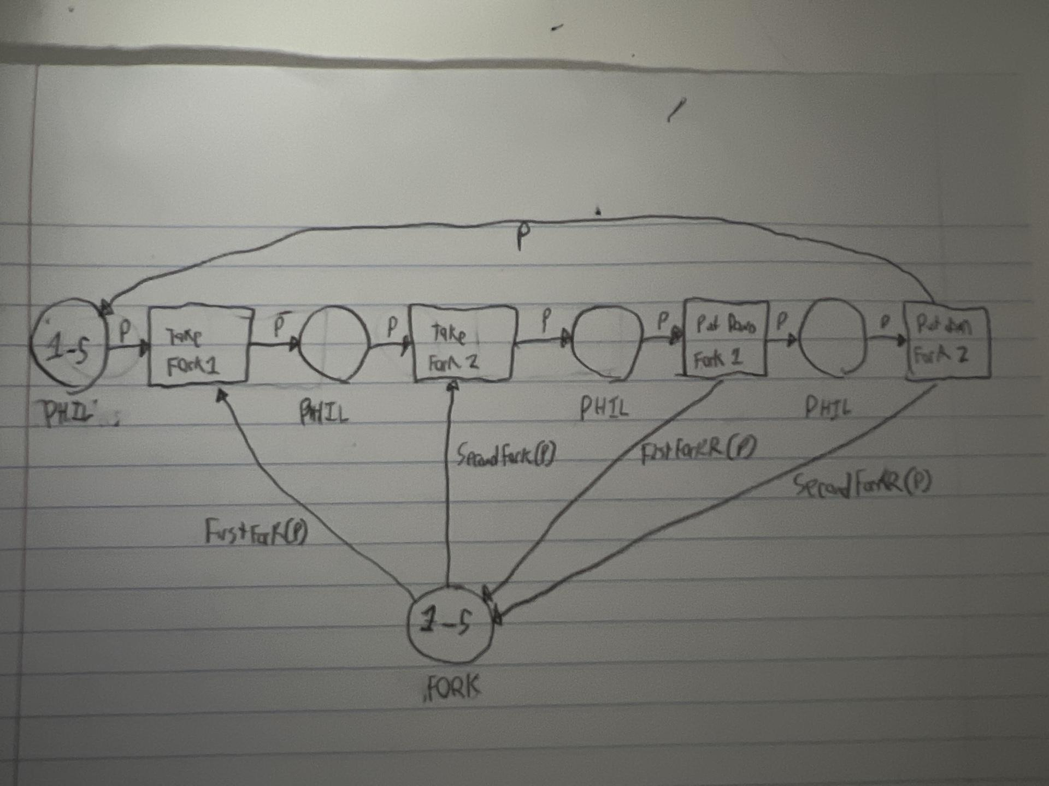

6)

Attached in q6.lts

7)

Attached in q7.lts

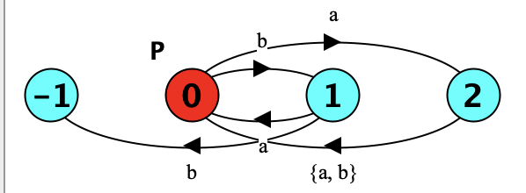

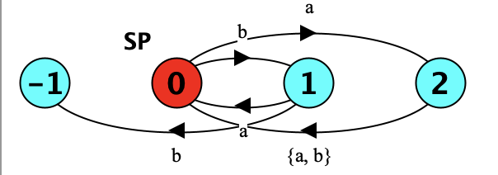

8)

a)

Attached in q8a.lts.

It does deadlock, with the trace

s_p.get_tobacco

s_p.get_match

s_p.roll_cigarrette

s_m.get_tobacco

s_m.can_deliver

s_p.smoking_completed

s_p.get_tobacco

s_p.get_match

s_p.roll_cigarrette

s_m.deliver_paper

s_m.get_paper

s_m.roll_cigarrette

s_p.deliver_match

s_p.can_deliver

s_p.smoking_completed

s_p.get_tobacco

s_p.get_match

s_p.roll_cigarrette

s_m.deliver_paper

s_m.deliver_tobacco

s_m.deliver_match

s_m.can_deliver

s_p.smoking_completed

s_p.get_tobacco

s_p.get_match

s_p.roll_cigarrette

s_t.deliver_tobacco

s_t.deliver_match

b)

Attached in q8b.lts

The safety property is violated. The trace is

s_m.can_deliver

s_m.deliver_paper

s_m.get_paper

c)

Attached in q8c.lts

This unfortunately still deadlocks. I followed the process given in the hint document, so I’m confused. But, if thats what the solution you guys have says, I’ll do it.

d)  
As the property is violated in b, and it still deadlocks in c, combining them will not solve the issue.